# Introduction

ZAKEKE is a third party that integrated with salesforce commerce cloud. ZAKEKE provide customization feature to customer. Customer can customize product according to his choice. E.g there’s lady bag, customer want to change bag’s front/back side patch with deferent color combination, he can change it easily and place order.

But merchant face a problem to identify and stock tracking of selected patch product in SFCC. To solve this issue patch product tracking service implemented. Following are the details to configure patch products

# Configuration for merchant

1. ZAKEKE Portal Configuration
   1. Go to images gallery and upload images
   2. Once you've uploaded them, click on the edit image button  
      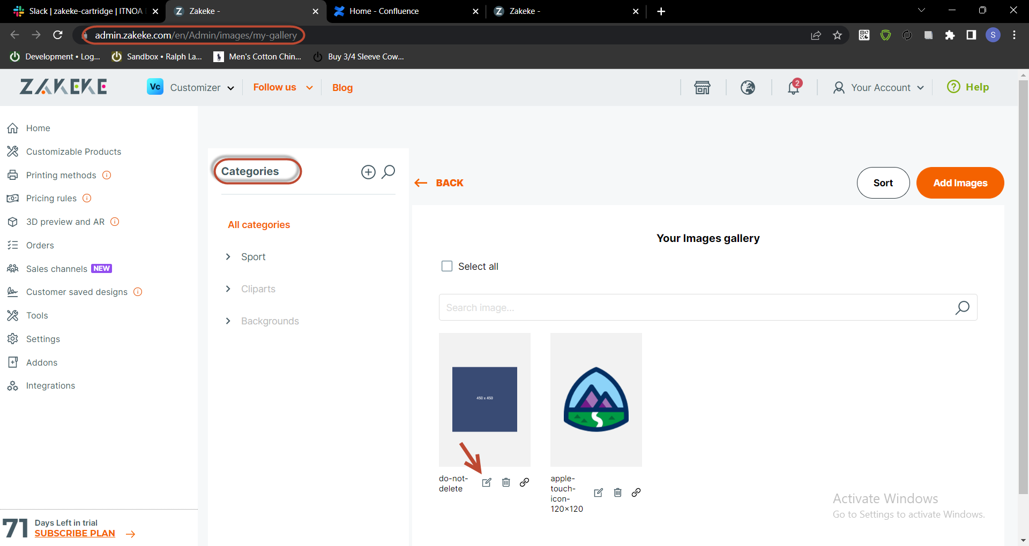
   3. Set SFCC product id in code field and click confirm button.  
      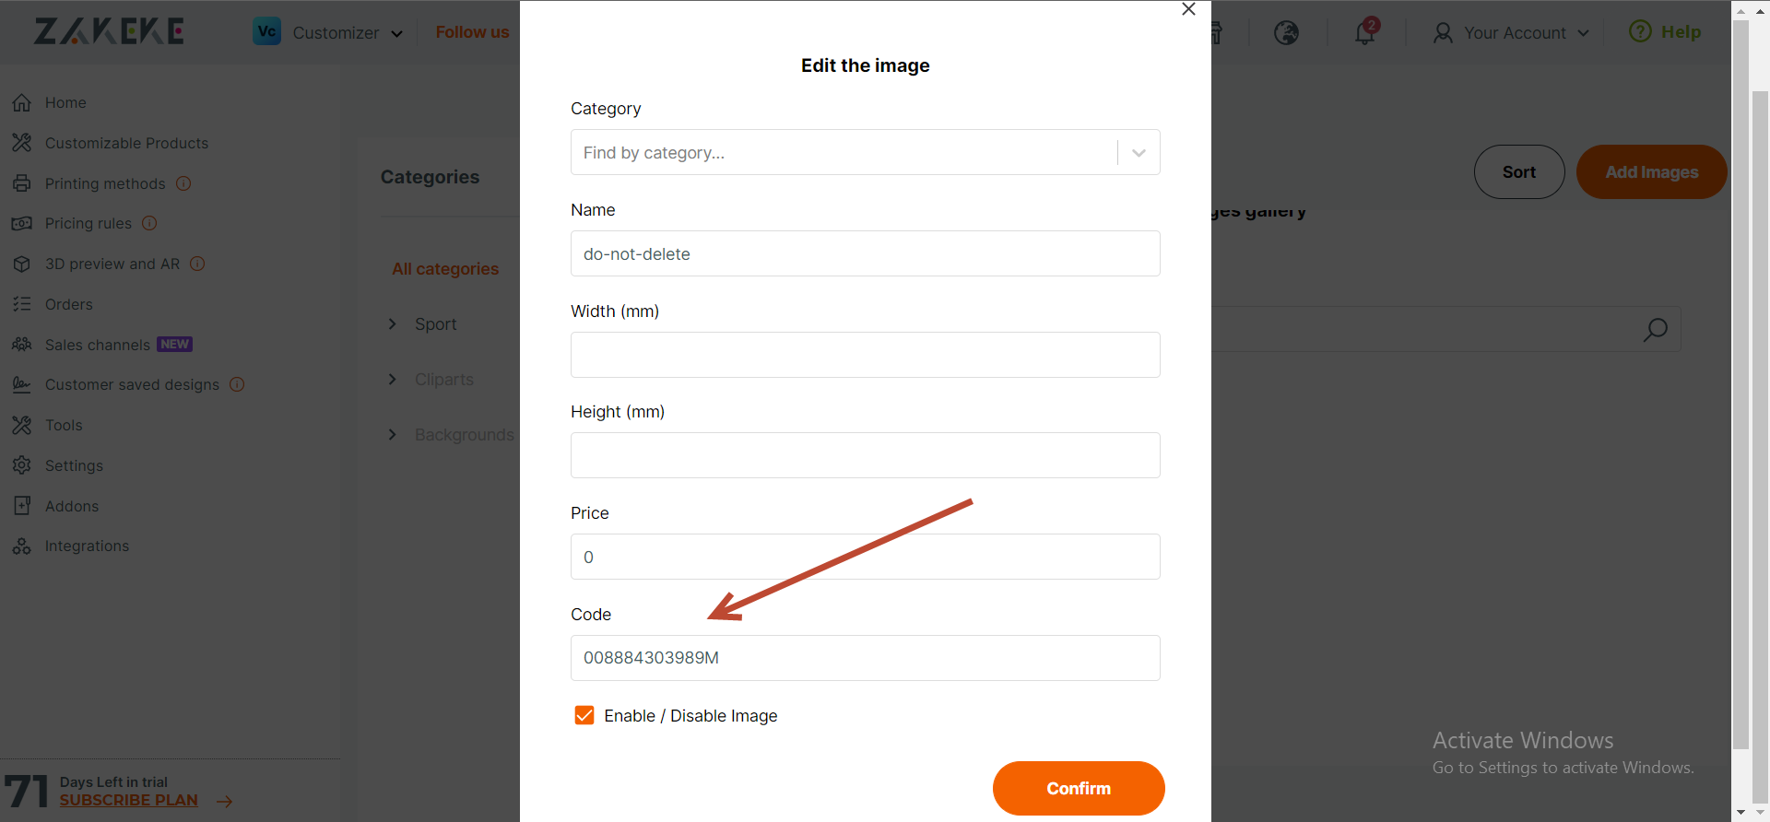
2. SFCC Configuration
   1. In custom preference enable stock tracking to fetch customized patch product details   
      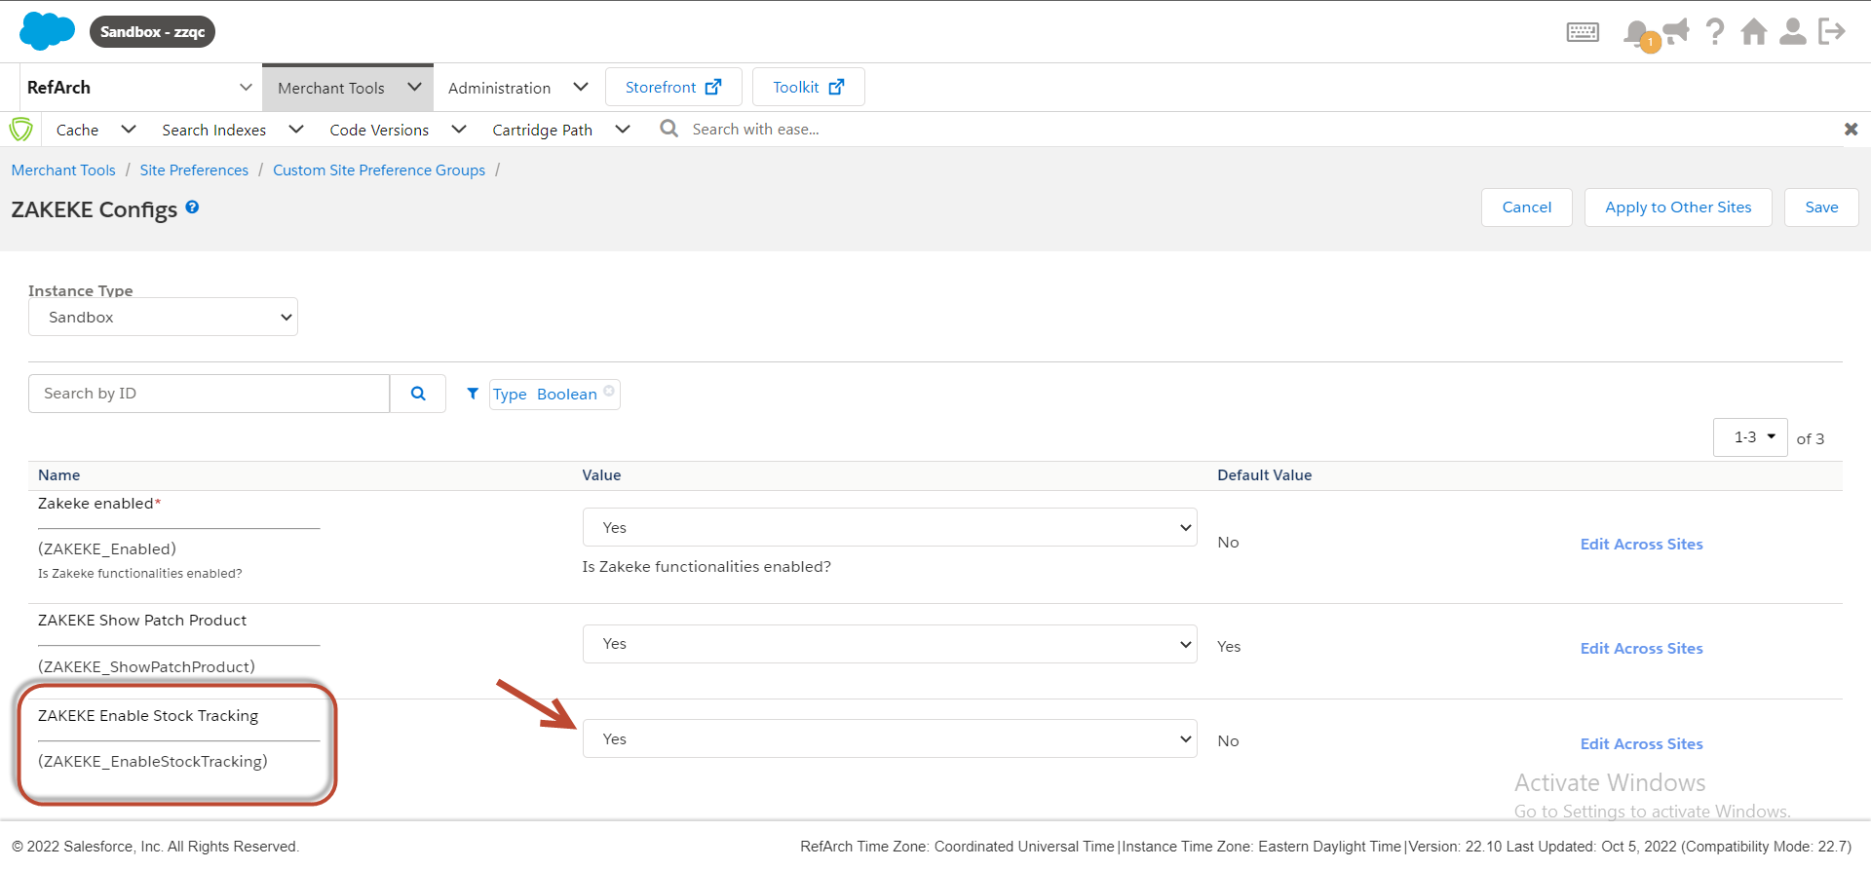
   2. By default customized patch product will not be visible to customer but merchant can allow to display on checkout by enabling Show Patch Product  
      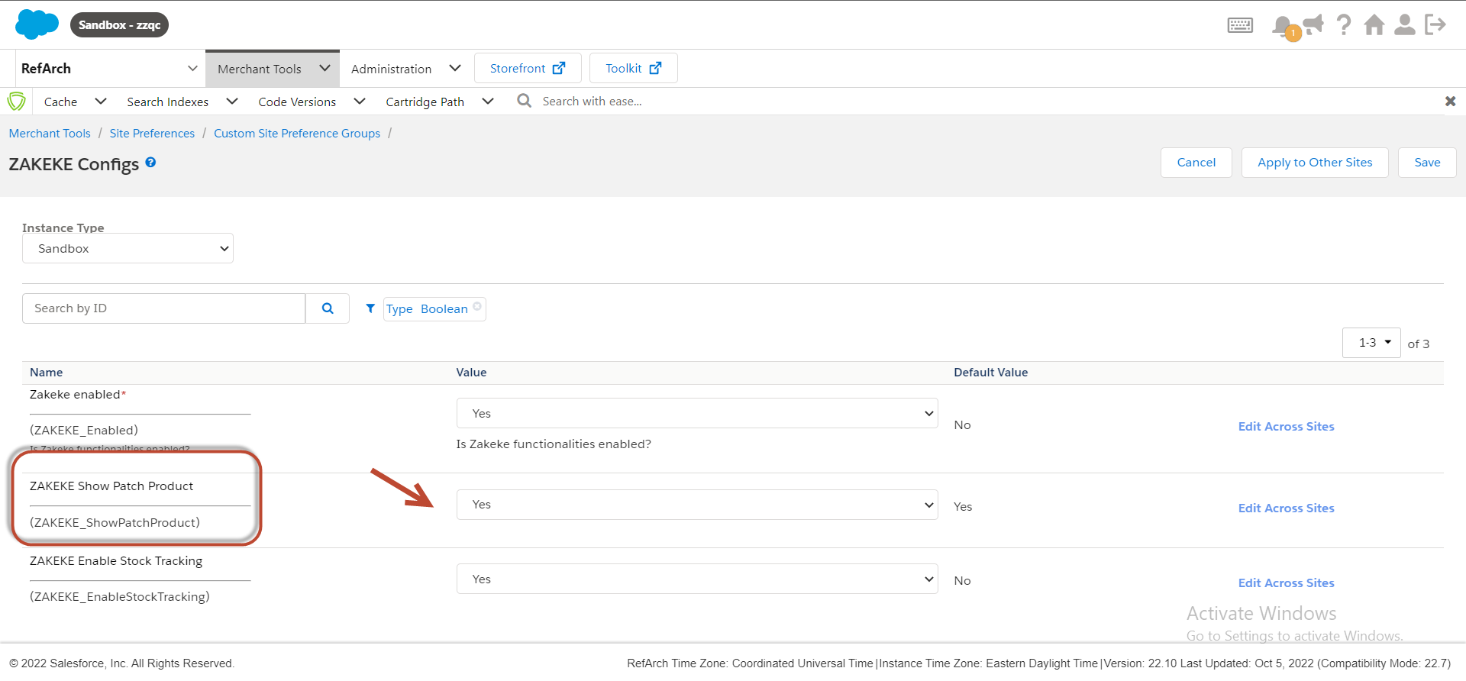

# Customer workflow

1. Customer will select variant on product detail page and click on customize button to customize product. 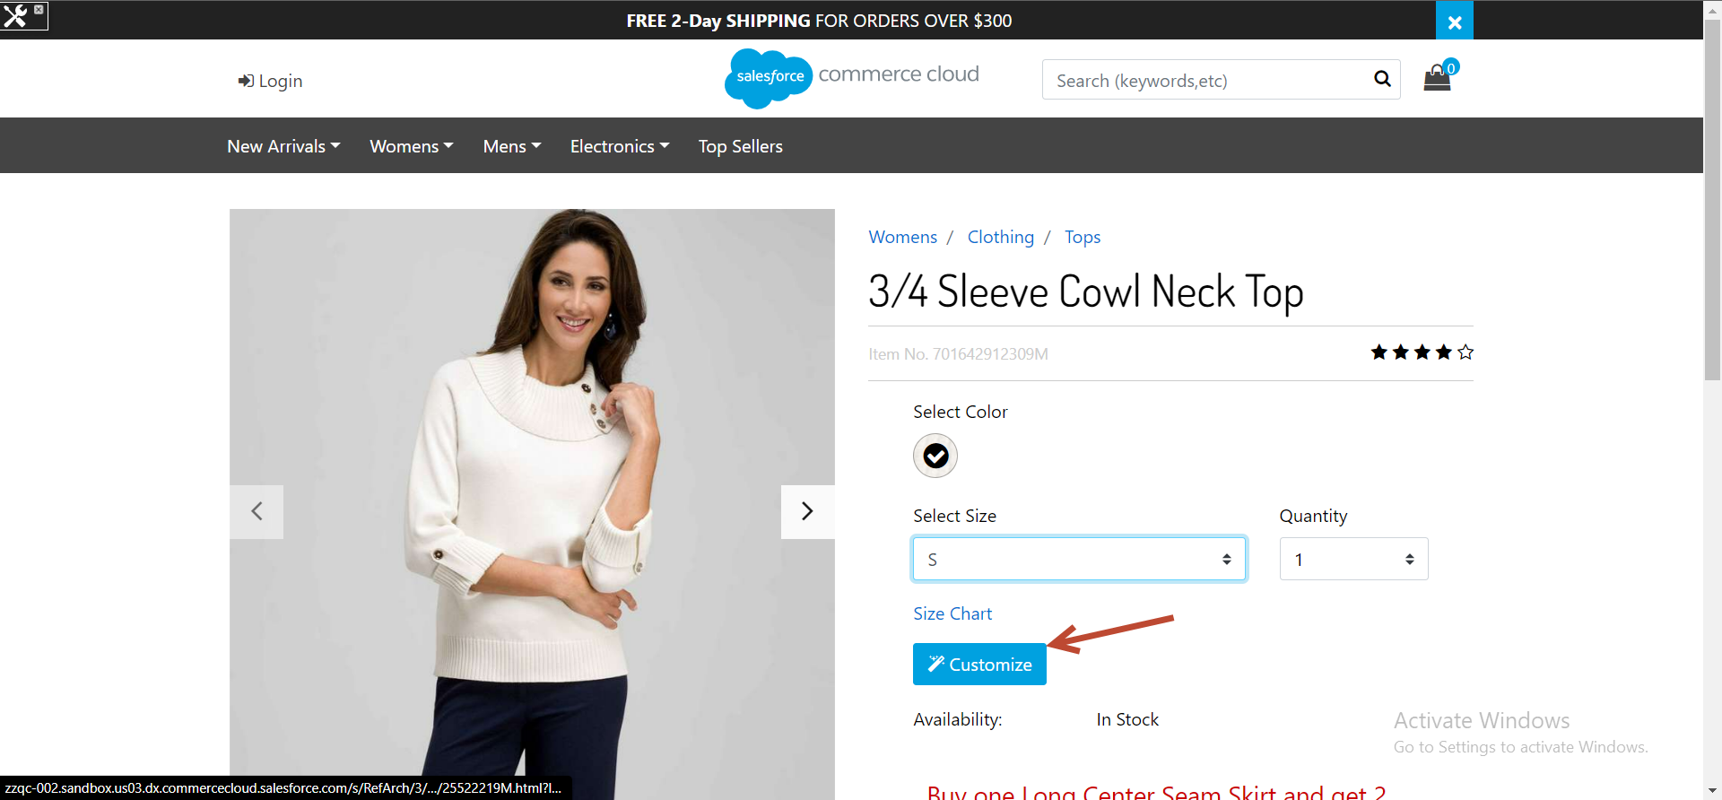
2. ZAKEKE Customize portal will open where customer select images  
   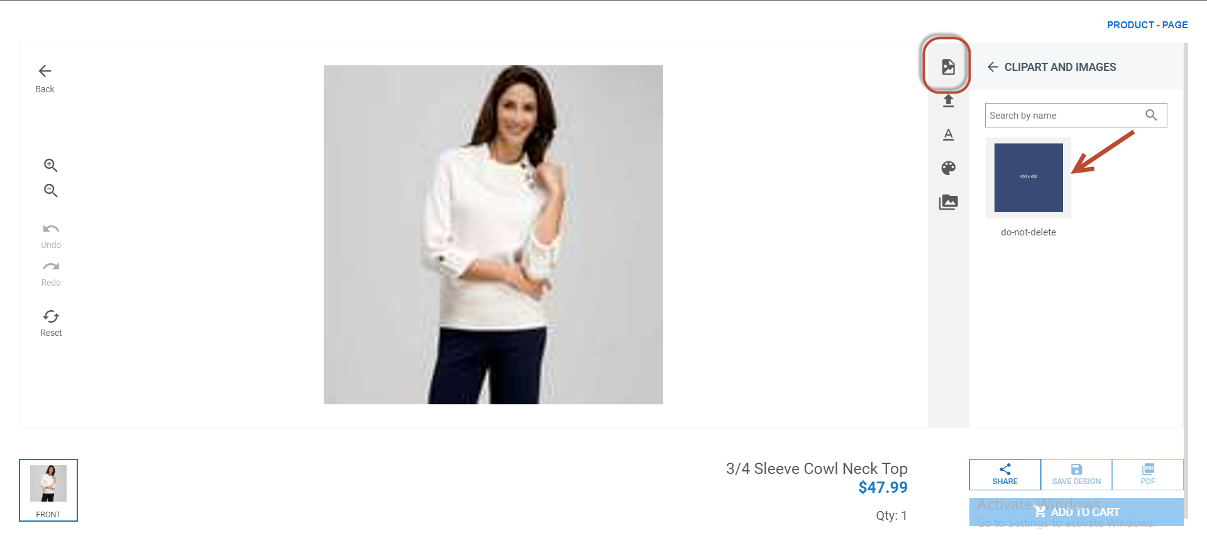  
   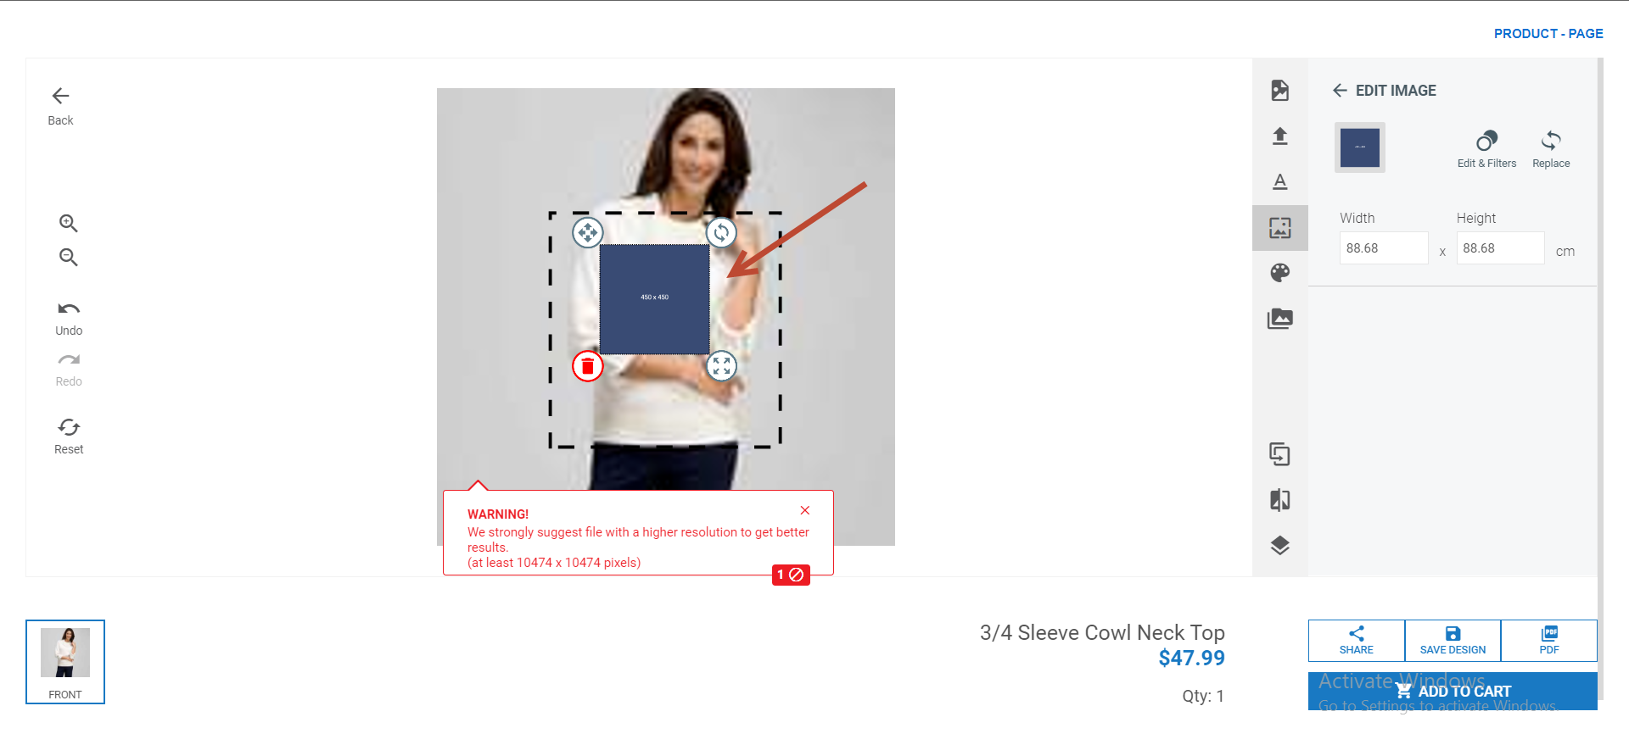
3. Now customer will click on **ADD TO CART**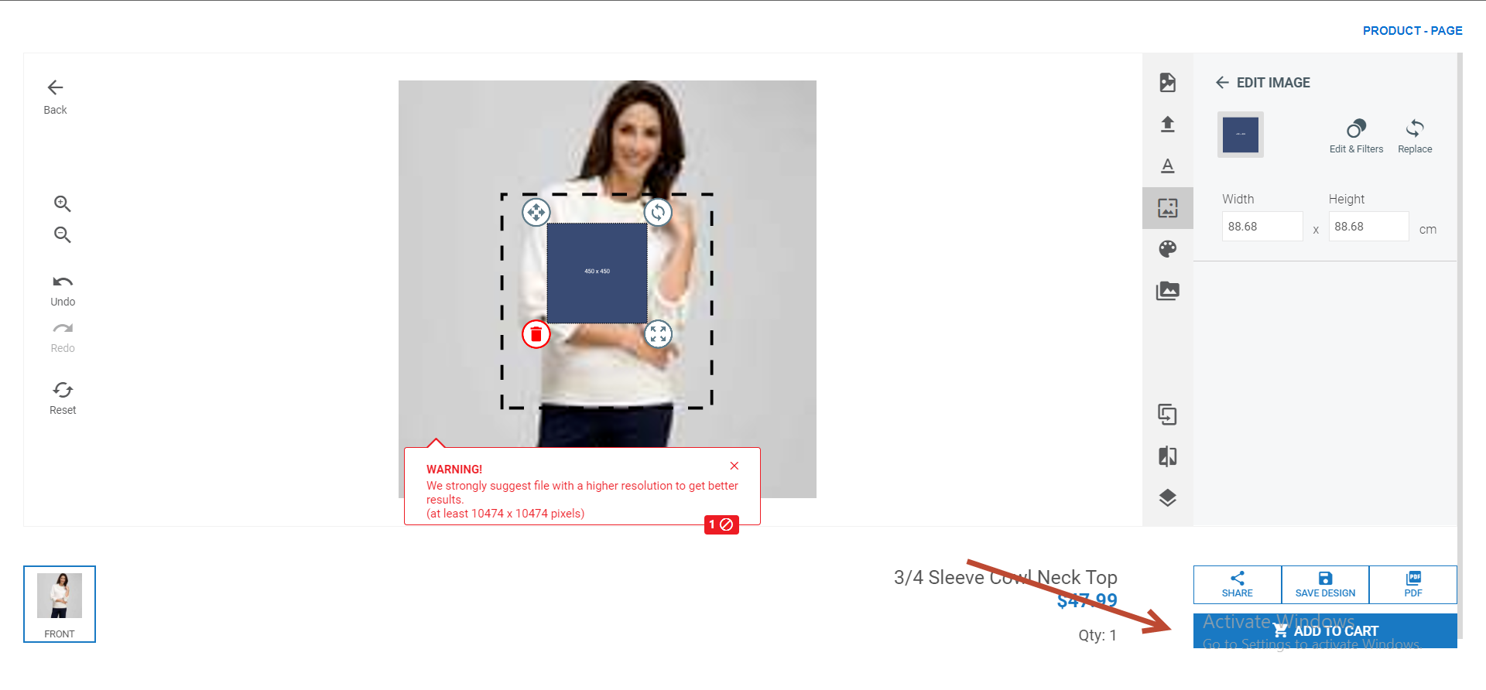
4. Customized product with patch product will be added into cart.  
     
   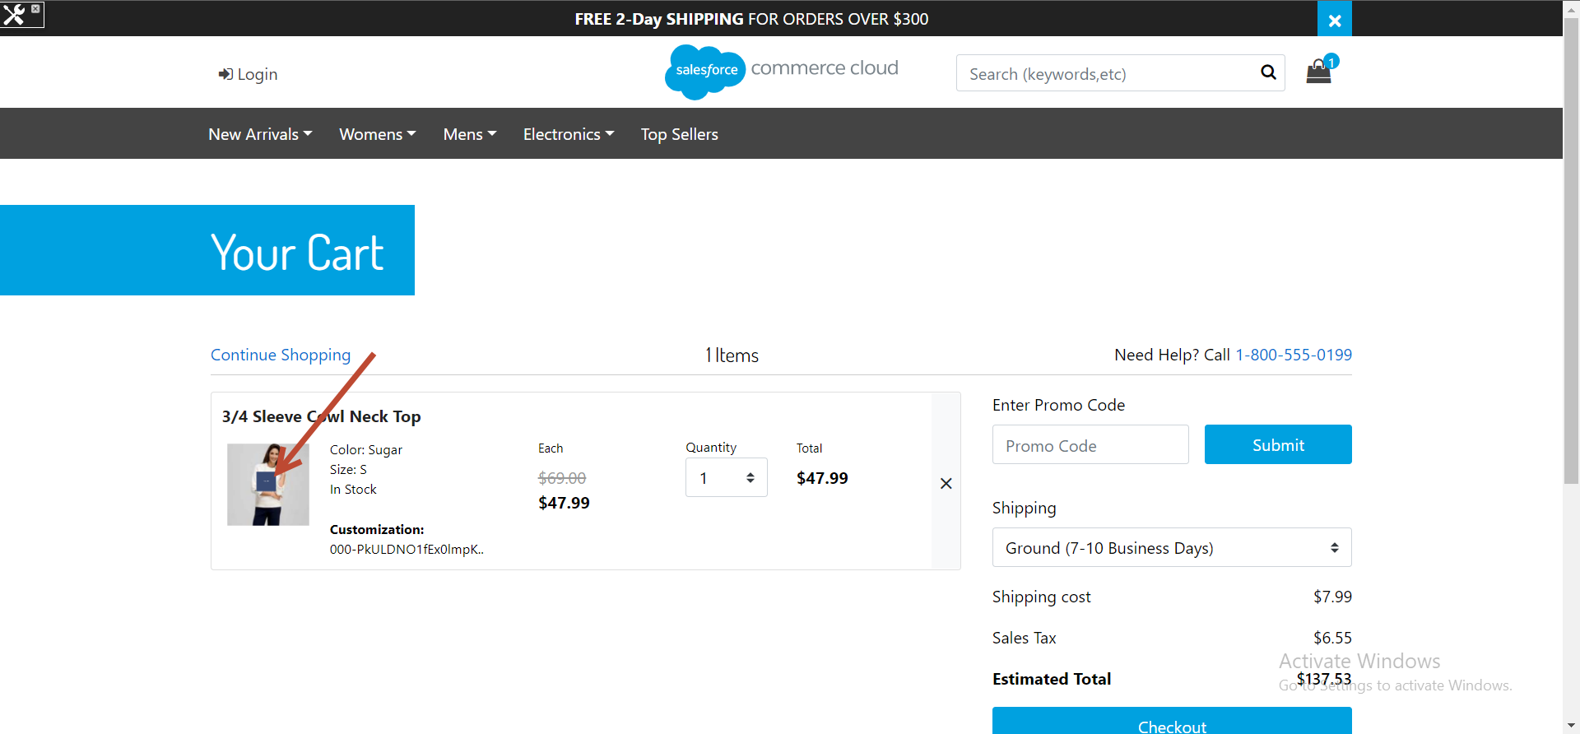
5. Further Customer will checkout to place order.

# End Result

1. Whenever a customer will place an order, patch product will also be part of order detail and merchant can see order details in Business Manager just like highlight in following image.  
   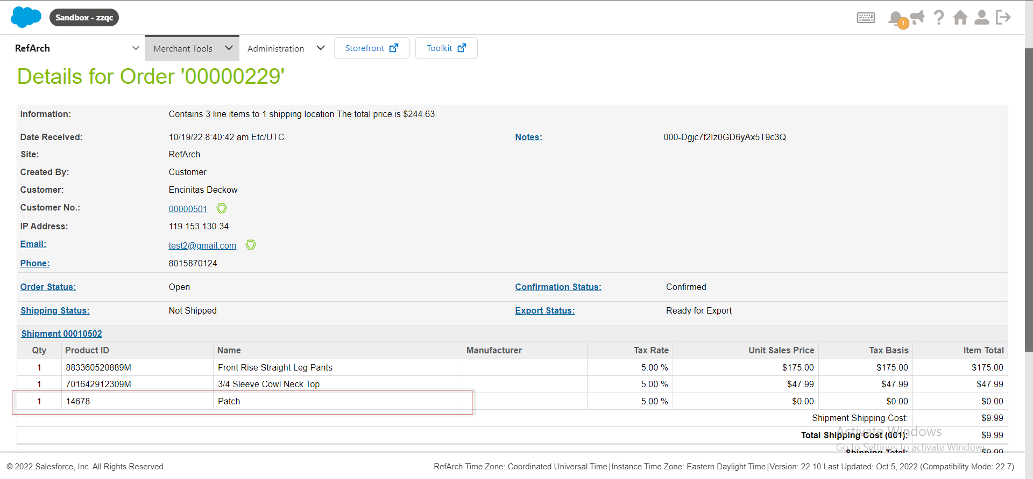

# Custom Code in int_zakeke_sfra

1. **Controllers**
   1. **Cart.js  
      Cart-Show >** set parameter to hide patch product on checkout page.  
      **Cart-MiniCart >** Cart total item calculations.  
      **Cart-RemoveProductLineItem >** when product removed from cart, patch product will also be removed from cart.  
      **Cart-UpdateQuantity >** when product quantity modified on cart page, patch product qty will also be updated.
   2. **Checkout.js  
      Checkout-Begin >** Show Patch Product Custom preference added to hide/show patch product on checkout page.
   3. **Order.js  
      Order-Confirm >** Show Patch Product Custom preference added to hide/show patch product on order confirmation page.
2. **Templates**
   1. **Cart/productCard/cartProductCard.isml**
   2. **Checkout/cart/miniCart.isml**
   3. **Checkout/productCard/cartProductCard.isml**

# Custom Code in app_storefront_core

Following templates were updated to provide patch tracking in Site genesis rest of the changes are in link cartridges. These updated templates can be found in documentation code section

**app_storefront_core/cartridge/templates/default/checkout/cart/cart.isml**

**app_storefront_core/cartridge/templates/default/checkout/cart/minicart.isml**

**app_storefront_core/cartridge/templates/default/checkout/components/minilineitems.isml**

**app_storefront_core/cartridge/templates/default/checkout/summary/summary.isml**

**app_storefront_core/cartridge/templates/default/components/order/orderdetails.isml**

**app_storefront_core/cartridge/templates/default/product/components/displayliproduct.isml**

Following file has been updated for mobile view.

**int_zakeke\cartridge\static\default\js\zakCustomizeCustomizer.js**